1. Start the "Command Prompt" from the Windows Start Menu (Start -> Accessories -> Command Prompt).

Black Mouse Cursor Png , Png Download - Mouse Cursor Png Icon, Transparent  Png - kindpng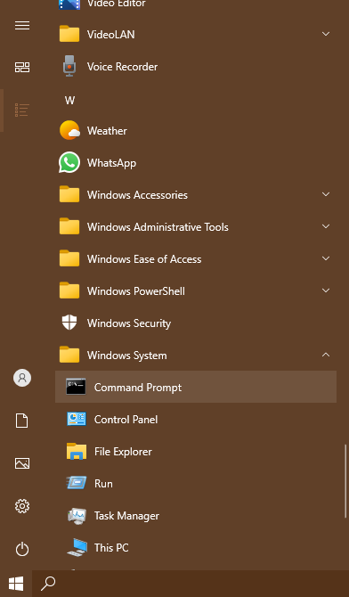

1. Use cd, cd.., cd/.. commands to navigate through the directories.

Create the Directory HCK in the desktop.

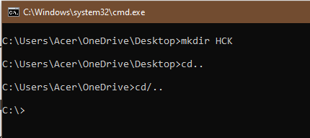

1. List the files in the current directories. Make use of commands cls, exit to clear the screen and exit the prompt.

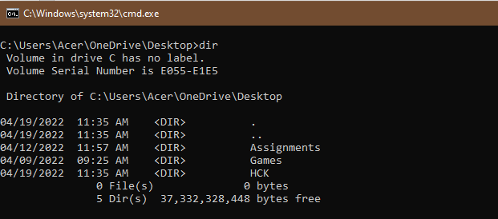

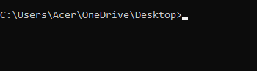

1. Create New.txt file containing text *“Herald College Kathmandu”*, in the HCK directory.

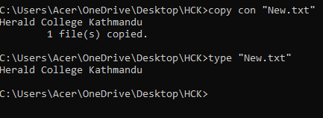

1. Delete New.txt file from HCK directory.

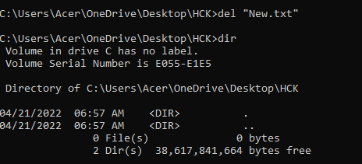

1. Remove directory HCK form the Desktop.

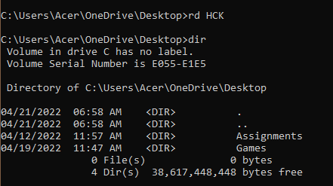

1. Create directory Kathmandu in the desktop containing file Swyambhu.txt, rename Swayambhu.txt as Barahi.txt

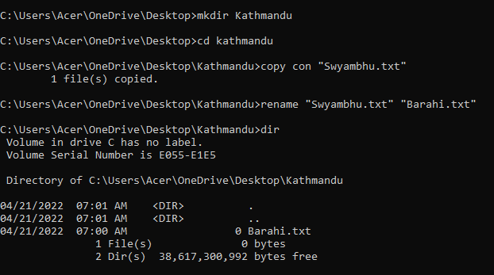

1. Create Directory Pokhara in the Desktop and move Bahari.txt of directory Kathmandu in directory Pokhara.

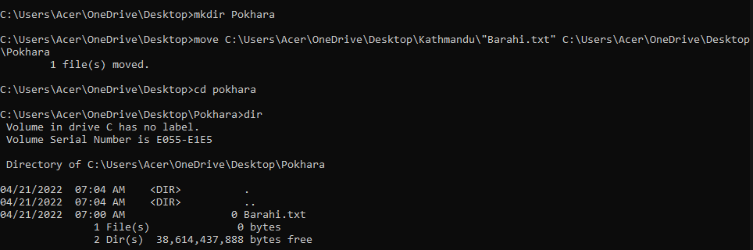

1. Write the python program in IDLE which takes two inputs form the user and returns sum of the two number. Run this program from command prompt.
2. Run the logsim program form the command prompt.

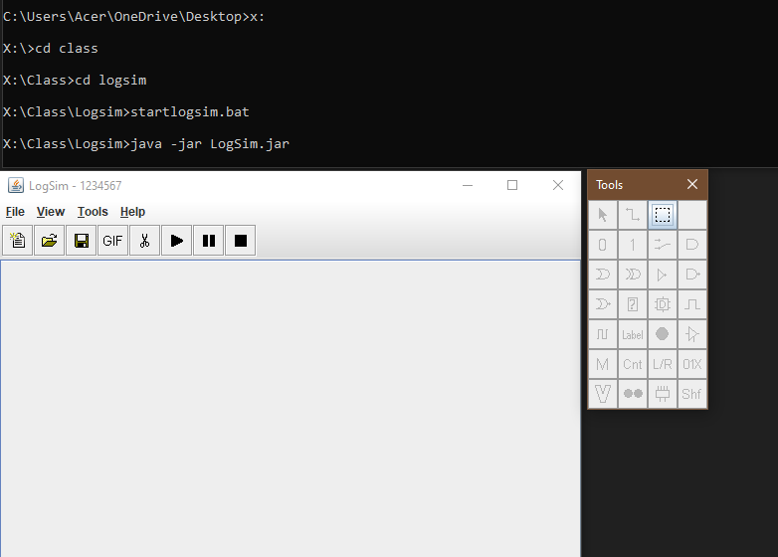

1. Create the following structure and take Screen sort. Paste your result here.

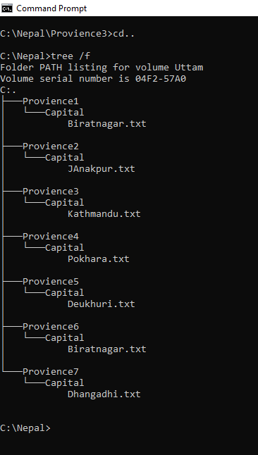

For more details about Commands you can type ***Help***which lists all the internal commands:

